**<< IS1901 - Microcontroller based ICT Project>>**

**PROJECT PROPOSAL REPORT**

**Level 01**

**<<Project Title>>**

Examiner <Mr. B. H. Sudantha> <Signature>

**Submitted by:**

Bachelor of Information Technology

Faculty of Information Technology

University of Moratuwa

**Table of Contents**

**Submitted by:** 1

1. Introduction 1

1.1 Problem in Brief 1

1.2 Significance of Study 1

1.3 Aim and Objectives 2

2. Literature Study 4

3. Proposed Solution 5

3.1 Features of the Proposed Solution 5

3.2 Components required for the proposed solution 6

3.3 Nature of the Solution 7

3.4 Solution Design 8

3.5 Resources 9

3.6 Workload Matrix 10

4. References 11

# Introduction

Ornamental plants are highly esteemed as gifts due to their ability to enhance the aesthetic appeal and tranquility of any given space. However, the fast-paced nature of contemporary lifestyles often impedes individuals from devoting ample time to the nurturing and maintenance of these plants. Furthermore, creating an optimal environment for plant growth can be challenging in the absence of proper knowledge and resources. This poses a notable predicament for both plant enthusiasts and those wishing to present plants as gifts.

## Problem in Brief

The primary objective of this project is to address this prevalent challenge by introducing a specialized automatic plant box, aptly named 'Verdant,' designed exclusively for specific ornamental plants. 'Verdant' endeavors to revolutionize the planting experience by offering users a novel approach to cultivating plants. As its name suggests, Verdant takes on the responsibility of ensuring the flourishing growth of plants, providing a meticulously controlled environment tailored to meet the unique needs of each plant species. Through the seamless integration of cutting-edge technology, Verdant automatically adjusts vital factors such as soil moisture, humidity levels, light exposure, and temperature to precisely meet the requirements of the plants it houses.

## Significance of Study

Ornamental plants are predominantly selected for their aesthetic value, and the vitality and well being of these plants are of utmost importance to their owners. With the introduction of 'Verdant,' owners can rest assured that their plants will thrive under optimal conditions. The intelligent system comprehensively monitors and regulates various environmental parameters essential for plant growth. By taking charge of the intricate aspects of plant care, 'Verdant' allows individuals to indulge in the visual splendor and serenity that ornamental plants bring, without the burden of constant maintenance.

## Aim and Objectives

**Aim:**

By employing advanced technology and automated functionalities, we aim to bridge the gap between people's desire to surround themselves with the beauty of nature and the challenges imposed by today's demanding lifestyles.

**Objectives:**

* To design and build a fully automated plant box that can provide the necessary environmental conditions and nutrients for ornamental plants to grow and thrive without human intervention.
* To provide a low-maintenance way for users to grow and enjoy ornamental plants without requiring extensive knowledge of plant care or gardening expertise.
* To offer a way for users with limited space, such as apartment or city dwellers, to bring the beauty of a diverse range of ornamental plants into their homes.
* To enhance the well-being and mental health of users by providing an indoor green space that can help purify the air, reduce stress, and improve overall mood.
* To increase access to rare and exotic ornamental plants that may be difficult to grow in a specific geographic location, allowing users to expand their knowledge of plant diversity and appreciate new and unique species.
* To allow users to personalize the experience of growing ornamental plants by selecting the type of plant they want to grow, monitoring its growth and health, and adjusting the environment to their desired settings.
* To provide an affordable and accessible option for users to add aesthetic value to their home or office space, as ornamental plants are known to enhance the look and feel of an environment.
* To create a mobile application or web interface for users to select the type of plant they want to grow, monitor the health and growth of their plant, and receive alerts and notifications when adjustments are needed.
* To develop a system for automatic fertilization and pest control that is safe for ornamental plants and does not harm the environment or human health.

# Literature Study

Grow boxes have gained popularity among individuals who lack available outdoor space or wish to cultivate plants, including vegetables, herbs, or flowers, during colder months. They offer protection against pests and diseases, providing an enclosed and controlled environment for optimal plant growth [1]. Most grow boxes are designed with opaque materials to block out light. However, the Verdant box stands out as a unique transparent system specially crafted for specific ornamental plants. Its transparent design adds aesthetic appeal to indoor spaces, showcasing the beauty of the plants it houses.

In terms of temperature control, many grow boxes rely on fans and high-intensity discharge (HID) lights [2]. These components help regulate the temperature but often have lower temperature ranges. To address this limitation, we have incorporated Peltier devices into our grow box. This advanced technology allows for precise temperature control, accommodating the specific requirements of the plants being cultivated.

# Proposed Solution

our suggested grow box stands apart from others on the market due to its specialization in cultivating specific ornamental plants. Its transparent design adds a touch of beauty to indoor spaces, while the incorporation of Peltier devices ensures precise temperature control. With automated humidity control, watering, and fertilizer systems, along with customizable lighting and a user-friendly interface, the grow box offers an all-in-one solution for creating the optimal growing environment for specific plants.

## Features of the Proposed Solution

* humidity control systems using both humidifiers and dehumidifiers. These technologies ensure that the humidity levels within the grow box are maintained at optimal levels, promoting healthy plant growth and mitigating the risk of moisture-related issues.
* To simplify plant care, integrated automated watering and fertilizer systems into the grow box. Soil moisture sensors and water pumps work in tandem to deliver adequate hydration to the plants, while liquid fertilizer systems provide essential nutrients as needed. This automation reduces the burden of manual watering and fertilizing, ensuring consistent and efficient plant nourishment.
* In addition, our grow box features a comprehensive lighting system that can be adjusted to accommodate plants' specific light requirements. This flexibility allows users to position the grow box in various locations while providing adequate light for optimal photosynthesis.
* To enhance user experience and convenience, a user interface that enables users to select and customize the environmental settings for the plants within the grow box. This user-friendly interface empowers individuals to create the ideal growing conditions tailored to their specific plants' needs.

## Components required for the proposed solution

Here you should mention the required resources for the solution design.

1. Temperature sensor

Using a temperature sensor in an automated plant system can be beneficial for monitoring and controlling the environmental conditions to ensure optimal plant growth.

1. Humidity sensor

Common types include capacitive, resistive, and thermal conductivity humidity sensors. Consider the humidity range, accuracy, and response time of the sensor

## Nature of the Solution

**Figure 01: Block diagram of the input, process and output**

## Solution Design

**Figure 02: High level design of the product**

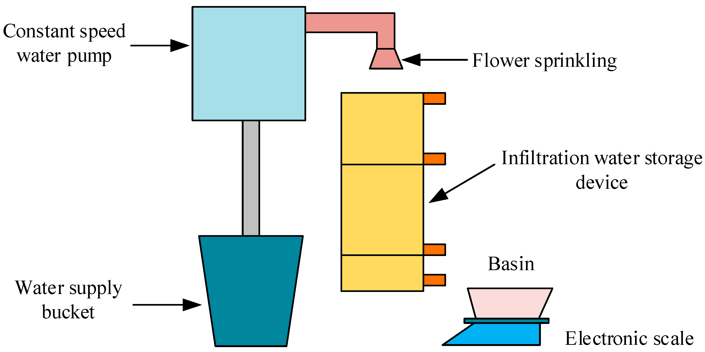

**Figure 03: A graphical or 3D view of the solution (if applicable)**

## Resources

* In here you should mention the required resources for the solution design with the budget allocation for those item

**Table 01: Components with budget allocation**

|  |  |  |  |
| --- | --- | --- | --- |
| **Component** | **Unit Price (LKR)** | **Unit** | **Total Price** |
| Soil moisture sensor | 220.00 | 1 | 220.00 |
| IR sensor | 180.00 | 1 | 180.00 |
| Relay 5V | 400.00 | 2 | 800.00 |
| Water pump | 280.00 | 1 | 280.00 |
| Ultrasonic mist maker | 1800.00 | 1 | 1800.00 |
| Box | 10000.00 | 1 | 10000.00 |
| Node mcu ESP8266 | 1650.00 | 1 | 1650.00 |
| 12V power supply | 4000.00 | 1 | 4000.00 |
| Heat sinks(dehumidifier) | 2000.00 | 1 | 2000.00 |
| PCB design | 840.00 | 1 | 840.00 |
| DHT22 / AM2302 Digital Temperature and Humidity Sensor Module | 620.00 | 1 | 620.00 |
| TEC1-12706 DC12V 60W Peltier Thermoelectric Cooler | 1190.00 | 3 | 3570.00 |
| Heat sink with  Cooling fan | 750.00 | 4 | 3000.00 |
| Heat Sink Compound 30g Thermal paste | 250.00 | 1 | 250.00 |
| Heat sink | 600.00 | 1 | 600.00 |
| Cooling fan | 280.00 | 1 | 280.00 |
| Air Pump | 1000.00 | 1 | 1000.00 |
| **Total** | | | 31090.00 |

## Workload Matrix

In here you should mention how the development of the solution has been divided among group members and the expected contribution of each member to the group project.

**Table 02: Workload Matrix**

|  |  |
| --- | --- |
| Registration Number | Assigned Responsibilities |
| 214252R | Tec1-12706 Peltier thermoelectric cooler  Air pump  PCB Designing |
| 214027H | Ultrasonic mist maker  IR Sensor |
| 214118M | DHT22 temperature and humidity sensor |
| 214147B | Soil moisture  5V Water pump |
| 214029P | Lighting System  User interface |

# References

[1] J. Li, P. Xie, B. Ai, and L. Li, "Multilingual communication experiences of international students during the COVID-19 Pandemic," Multilingua, vol. 39, no. 5, pp. 529-539, 2020.

[2] Y. Zheng, "Mobilizing foreign language students for multilingual crisis translation in Shanghai," Multilingua, vol. 39, no. 5, pp. 587-595, 2020.

[3] E. Byrne, E. Elliott, R. Saltus, J. Angharad, "The creative turn in evidence for public health: community and arts-based methodologies," Journal of Public Health, vol. 40, no. suppl_1, pp. i24–i30, Mar. 2018. DOI: 10.1093/pubmed/fdx151

[4] "Opportunities for Human-centered Evaluation of Machine Translation Systems," Findings, 2022.